Original Article

The Effect of Rational Emotive Behavior Therapy (REBT) Intervention on Reducing Anxiety and Improving the Quality of Selft-Coping of Pregnant Women in the Working Area of The Nilam Sari Community Health Centre, Bukittinggi City 2015 : a Quasy – Eksperimental Study
Sari Rahma Fitri ¹, Hadyana Sukandar ², Endang Sutedja³, Farid Husin ⁴
¹ Bachelor Two of Midwifery Student, Faculty of Medicine,Padjadjaran Univerisity, Bandung, Indonesia
² Department of Public Health Science, Faculty of Medicine, Padjadjaran Univerisity, Bandung, Indonesia
³ Department of Public Health Science, Faculty of Medicine, Padjadjaran Univerisity, Bandung, Indonesia
4Department of Midwifery, Faculty of Medicine, , Padjadjaran Univerisity, Bandung, Indonesia

Article Information | A B S T R A C T
Received: Juni 28, 2026  Revised:  Accepted: | Background: One of the main indicators of successful healthcare services is the decline in the Maternal Mortality Rate (MMR). However, in Indonesia, it remains relatively high. One factor affecting maternal health is excessive anxiety. Various studies worldwide have shown that excessive anxiety during pregnancy negatively impacts the quality of the pregnancy and can lead to complications in the child's mental and emotional development.
 | Objective: This study aimed to determine the effect of Rational Emotive Behavior Therapy (REBT) intervention on reducing anxiety and improving the coping skills of pregnant women at the Nilam Sari Community Health Center in Bukittinggi City.
Keywords
Rational Emotive Behavior Therapy, Anxiety of Pregnancy Women, Coping Self, Mental Health at Antenatal care | Method: The method used in this study is a Quasi Experiment non-randomized pretest-post test design without control with a sample of 16 pregnant women in the moderate to very high anxiety category. The measuring instruments used were the Pregnancy Anxiety Scale (PSA) questionnaire, the Pregnancy Related Anxiety Scale (PRAS), the Revised Ways Of Coping Scale (WCQR), and the Rational Emotive Behavior Therapy (REBT) Intervention Module. Data analysis used the Friedman Test, Wilcoxon and Marginal Homogeneity Test, Odds Ratio with Confidence Interval.  Result :The results of the study showed that there was a significant influence of the Rational Emotive Behavior Therapy (REBT) intervention on reducing anxiety and increasing the quality of self-coping of pregnant women with a p value <0.05.  Conclusion: This study indicates that Rational Emotive Behavior Therapy (REBT) has a significant effect on pregnant women with moderate to very high levels of anxiety. The intervention is effective in reducing anxiety and improving coping skills among pregnant women.  The observed changes are characterized by a shift from irrational to rational thinking patterns, leading to more realistic and adaptive cognitive responses. This cognitive restructuring contributes to improved emotional stability and enhanced coping capacity in managing pregnancy-related stressors.  Therefore, REBT can be recommended as an effective psychological intervention within antenatal care services for the early identification and management of anxiety in pregnant women. It is also suggested that structured mental health care components be integrated into maternal health services as part of comprehensive antenatal care. Such integration is expected to strengthen psychologically based midwifery care and support efforts to reduce maternal and neonatal health risks.
Correspondence
Phone: +62 8983603598
E-mail:ayirahma2014@gmail.com

INTRODUCTION

One of the main indicators of the success of health services in Indonesia is the decline in the Maternal Mortality Rate (MMR). According to the 2003-2007 Indonesian Demographic and Health Survey (IDHS), the MMR in Indonesia remains quite high, at 228 per 100,000 live births. Many factors contribute to the high MMR, one of which is the mother's emotional state during pregnancy and delivery. Psychological issues, such as excessive anxiety during pregnancy, have long been considered insignificant.¹

The WHO states that although the prevalence of anxiety in pregnancy ranges from 10 to 15% in all developing and low-income countries worldwide, if not specifically addressed, this issue remains poorly managed.²

Pregnancy is a transitional period in a woman's life, marked by physiological, cognitive, emotional, and social changes. Therefore, it is natural for pregnant women to worry about the future. However, it is important to emphasize that this worry can contribute to excessive anxiety, becoming one of the most potent triggers for childbirth, with negative impacts and detrimental effects on the baby's development. It may not seem like a significant problem, but when examined, it has a significant impact on long-term survival^{.3-6}

Women who experience stress and anxiety during the third trimester of pregnancy are at increased risk of congenital abnormalities, such as cleft palate failure, cesarean section, instrumental delivery, premature birth, low birth weight (LBW), and long-term behavioral and emotional disorders in children.⁵⁻¹⁰

The results of a study of 230 primigravida subjects showed that anxiety stems from three issues: anxiety related to the birth process, anxiety related to physical and mental disabilities in the fetus, and anxiety related to parenting.5
In Indonesia, the reality is that psychological care services are very limited. Anxiety issues are generally rarely detected properly in pregnant women in all health services, or even none at all. Although they are related to other professions such as psychologists, midwives also play a crucial role in this. As providers of basic care during pregnancy, midwives are also provided with education on how to provide basic care for pregnant women, such as the need for physical and psychological comfort. This is incorporated into their thought processes. However, there are no proper procedures for its implementation, so it doesn't function effectively. Yet, the standard care services already include counseling aspects that should be helpful to patients. The counseling efforts commonly found for pregnant women are merely general recommendations per trimester. They are not tailored to the specific needs of pregnant women, such as reducing anxiety, so they appear less focused or well-programmed, and therefore haven't yielded meaningful results^{.6-10}

One example is observed at the Nilam Sari Community Health Center in Bukittinggi City. Observations of every pregnant woman who attended a prenatal checkup revealed that 8 out of 10 women reported experiencing anxiety during their pregnancy. The service was deemed inadequate, even non-existent, and there was a lack of empathy for their anxieties.

Excessive worry and anxiety during pregnancy are the result of irrational thoughts that pregnant women believe. These excessive irrational thoughts, sometimes without their awareness, are not always proven to be true, yet they are strongly believed. Therefore, if a pregnant woman has excessive, irrational thoughts about her pregnancy and the things she experiences, it will lead to increased anxiety and worry. Consequently, her desires tend to increase. When anxiety increases, pregnant women's coping tends to become maladaptive, meaning they are unable to address challenges or problems with inappropriate and negative approaches. This is further emphasized by Stuart (2009), who stated that a person's efforts to adapt to stressors also depend on their coping skills. Coping is described as a strategy used by a person to deal with everyday or extraordinary situations in their mind and environment.⁷

Ellis states that all forms of emotion and behavior are the result of the interpretation of the thoughts (cognitive assumptions) they hold within themselves, and sometimes, without realizing it, they adopt irrational thoughts or beliefs developed by the individual. This study aims to analyze differences in anxiety levels and stress-coping skills in pregnant women before and after the implementation of Rational Emotive Behavior Therapy (REBT), and to examine the effect of REBT interventions in reducing anxiety and improving stress-coping skills in pregnant women.

Therefore, this study is expected to provide an overview of the effectiveness of REBT as a psychological approach in addressing anxiety during pregnancy and improving the adaptability of pregnant women in dealing with stress during pregnancy. It is also hoped that this will create a maternal mental health corner in antenatal care services and other services such as integrated health posts (Posyandu) and a series of care services.

Cognitive-Behavioral Therapy is a form of psychotherapy that integrates cognitive and behavioral therapy to help individuals make changes. These changes not only affect actual behavior but also the underlying thoughts, beliefs, assumptions, beliefs, and attitudes that lead to emotional distress. It can be applied to various mood and anxiety disorders^{.6,32,33}

The basic assumption of the Cognitive-Behavioral approach is that there is a mutually influential relationship between cognitive processes (what is thought) and feelings (emotional experience), as well as the physiological and behavioral responses experienced (Roth et al., 2002). For example, when someone has the flu, they might think they are weak and unable to do anything, leading to body odor, sensitivity, and seizures. They might then skip work and stay at home. While staying at home, they might become sad and depressed, believing that they have done nothing beneficial for themselves or their family that day. The goal of the cognitive-behavioral approach is to learn to recognize maladaptive and irrational thoughts, assumptions, and beliefs that exacerbate negative emotions, and recognize that these thoughts and beliefs are dysfunctional, inappropriate, and completely harmful. It also helps clients learn to find better ways to manage excessive anxiety and worry. Health education or psychoeducation can be carried out by anyone who understands the principles of behavior formation and change according to cognitive and behavioral psychology theories. In education at the Diploma IV midwifery, one of the topics also discusses cognitive and behavioral approaches in teaching, so understanding both approaches is important. ^{30,32}

Most existing studies have focused on nurturing care practices in healthy or community-based populations, leaving a critical knowledge gap about how caregiving influences growth during acute illness. Acute illness represents a dynamic physiological condition in which metabolic stress may attenuate the immediate benefits of caregiving. However, nurturing care may still play an important role in supporting recovery and preventing further deterioration of growth.

REBT was pioneered by Dr. Albert Ellis in 1950, a clinical psychologist specializing in psychoanalysis. Originally called Rational Therapy, it became Rational Emotive Behavior Therapy in 1990. REBT is a blend of cognitive and behavioral therapies. Although developed separately, it shares many similarities with cognitive therapy. Over the past half century, REBT has been significantly developed and continues to evolve.

Rational Emotive Behavior Therapy is based on the assumption that cognition, emotion, and behavior are inseparable, as it is essentially an integrated and holistic method. When an individual feels, thinks, and acts, when an individual acts, they feel and think. When they think, they feel and act. This is because humans rarely just think or feel. Everything is continuous.³⁶

REBT therapy seeks to help individuals transform irrational beliefs into rational beliefs and improve emotional and behavioral functioning so that they become consistently better and more integrated. According to Ellis, every person has the potential to possess rational and irrational beliefs. When the frequency of irrational beliefs exceeds the intensity of rational beliefs, the individual will become disturbed compared to individuals who have fewer and weaker irrational beliefs. When an individual is able to transform irrational beliefs into rational beliefs in therapy, they have successfully helped themselves and significantly reduced their disturbance. Therefore, it can be concluded that when someone thinks and behaves rationally, they will be effective, happy, and capable. When thinking irrationally, they will be ineffective.

According to Froggatt (2005), REBT is one of several therapies that originates from the mind and behavior. REBT is not merely a technique but a comprehensive theory of human behavior. REBT is based on the concept that emotions and behavior are the result of thought processes that allow humans to modify them, as a process to achieve different ways of feeling and acting. A person's emotional reactions are largely driven by conscious and unconscious evaluations, interpretations, and philosophies. Psychological or emotional barriers result from illogical or irrational thinking, where the emotions that accompany an individual's prejudiced thinking are highly personal and irrational.

Froggatt (2005) proposed a biopsychosocial causal explanation, a combination of biological, psychological, and social factors that influence a person's feelings and behavior. REBT explains that a person's biological state also influences their feelings and behavior. This is an important point that therapists need to remember to understand the extent of human change. From the explanations above, it can be seen that REBT is based on the concept of emotions and behavior, which are the result of a person's thinking process about what they think, assume, and believe about themselves, others, and their environment. This is influenced by biological, psychological, and social factors, and is reflected in how individuals feel and act toward the problems they face.⁹

Albert Ellis argues that what individuals need to change to overcome emotional and behavioral problems are the irrational beliefs they develop themselves. Generally, these beliefs exist outside of conscious awareness. Beliefs are habits or automatic rules that consist of basic rules about how to live life in the world. With practice, humans can explore these beliefs beneath their conscious awareness. Based on this understanding, Ellis developed REBT therapy to help individuals transform irrational beliefs into more rational ones.⁸

A pregnant woman's emotional state throughout pregnancy and birth is one of the factors that can lead to complications later in life. Women who experience stress and anxiety during pregnancy are at increased risk of congenital abnormalities, including cleft palate failure, cesarean section, instrumental delivery, premature birth, low birth weight (LBW), and long-term behavioral and emotional disorders in the child.

Pregnancy and childbirth are natural and painful processes. However, many women experience this pain more than necessary due to feelings of panic and stress. This is called the fear-tension-pain concept. Fear creates tension/panic, which causes muscle stiffness and ultimately pain.

Pregnancy is a transitional period in a woman's life, marked by physiological, cognitive, emotional, and social changes. Therefore, it's natural for pregnant women to worry about the future. However, these worries can contribute to higher levels of anxiety, becoming one of the most potent psychological predictors of birth complications and detrimental to the baby's development. While this may not seem like a significant issue, when examined, it has a significant impact on long-term survival.³

Midwives play a crucial role in providing care to pregnant women in accordance with Maslow's basic human needs. Their competence encompasses not only meeting and early detection of physiological needs but also caring for the psychological needs of pregnant women, which must be met. This is even included in the learning objectives from the beginning of their education. If this is not implemented effectively, such as if anxiety issues are not properly addressed, the risk of feared complications can arise later.
Stuart (2009) states that a person's efforts to adapt to stressors also depend on their coping skills. Coping is described as a strategy used by someone to deal with everyday or extraordinary situations in their mind and environment.⁷

This excessive worry or anxiety is an irrational thought that occurs in pregnant women. Therefore, if thoughts become negative or irrational beliefs about a situation, this anxiety directly arises and even increases, affecting the mother's coping, leading to maladaptive behavior.

Ellis stated that all forms of emotion and behavior are the result of an individual's interpretation of their internal thoughts (cognitive assumptions), which they believe in, and sometimes unconsciously adopt irrational thoughts or beliefs developed by the individual themselves.

Thoughts generally exist outside of conscious awareness. Thoughts are habits that automatically consist of basic rules for how to navigate life. With practice, humans can explore these subconscious thoughts. Based on this opinion, Ellis developed a therapy called REBT to help people transform their irrational beliefs into more rational ones by disputing these irrational thoughts, enabling them to transform them into rational thoughts. It is hoped that this intervention method will reduce anxiety experienced by pregnant women and directly promote adaptive coping in solving problems within their minds and their surroundings.^{8,9}

METHOD

Study Design
This study was a quasi-experimental study with a nonrandomized pretest-posttest without control group design, a plan that administers treatment to one group without a comparison. Treatment effectiveness is measured by comparing pretest and posttest scores. A pretest and posttest without control group design is a commonly used research design, with the aim of this study being to determine the effect of psychoeducation on reducing anxiety and coping skills in pregnant women.
Zimney states that a psychological experiment is an objective observation of a phenomenon that is designed to occur under strictly controlled conditions, where one or more factors are varied while others are held constant. According to Cristensen (2004), the research design used is a single-case study design, which is used for only one subject or one group of subjects to examine the effects of treatment in experimental research. The researcher focused on one group of sixteen (16) subjects without a control group. Because more than one subject was given treatment, the results were compared using a graph to represent the subject's condition.37
The type of design used in this study was a change criteria design, which involves data collection with measurements in the baseline phase and continued measurements in the treatment phase, as explained in the following table 1 :
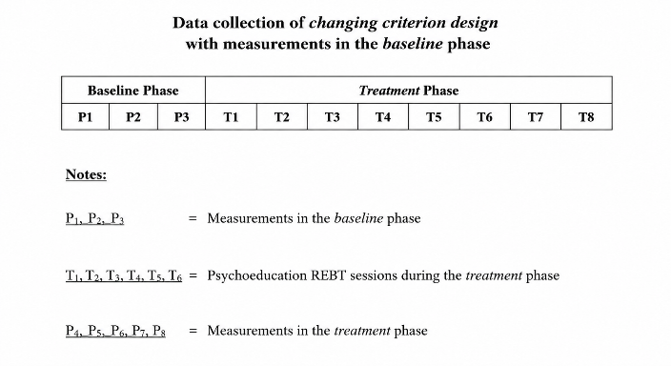

Sett The baseline phase here aims to measure the median of the mother's anxiety score between the first and third measurements. Although there are standards for Rational Emotive Behavior Therapy interventions, we as intervention providers have a starting point, and each mother's needs are different. The baseline phase can be conducted three times a day, or once every five days until the fifth day. It depends on the needs, as meeting the needs of each mother under care varies depending on their anxiety level.

Hartman and Hall, in Cristensen (2004), state that it is used by considering the measurement timeframe for both the baseline and treatment phases, as well as the criteria for change, self-assessment, and social evaluation. The baseline measurement timeframe is longer than that for treatment, ensuring that behavioral changes are purely due to treatment and not maturation or history.ing and Participants

Variable, Instrument and Measurement
1.) Criteria for Change in the Treatment Phase
a. Session I:
A decrease in anxiety symptoms is expected in the next measurement. This is based on the cognitive domain in session I. Because the researcher taught the ABC concept of REBT, the subject's understanding of this concept will influence the subject's cognitive outlook on life.
b. Session II:
A decrease in anxiety is expected. This is based on the second meeting, where the researcher and the client identified the client's irrational thoughts, enabling the client to recognize that these irrational thoughts were causing the client to experience excessive anxiety during her pregnancy.
c. Session III:
In the third meeting, the researcher, as therapist, refuted the subject's irrational thoughts. The subject is expected to be able to replace their irrational thoughts with rational ones. This will result in a decrease in anxiety symptoms, a decrease in feelings of foresight, a decrease in cognitive domain disturbances, and a decrease in loss of interest in meaningful activities.
d. Session IV:
After the fourth meeting, a decrease in anxiety symptoms is expected. Based on this meeting, the therapist strengthens the client's ability to maintain rational thinking using emotive techniques. It is expected that there will be a decrease in symptoms of emotional dysfunction and hypervigilance, in addition to a decrease in symptoms that had also decreased in the previous session.
e. Meeting V:
Measurements after this meeting are expected to show a decrease in symptoms and an additional decrease in symptoms in the area of ​​social functioning.
f. Meeting VI:
It is expected that there will be a decrease in symptoms from the previous meeting.
Behavioral changes during the treatment phase can be seen through interviews and observations during the sessions, known as self-assessment and social evaluation. Cristensen (2004) also stated that, like other designs, this design has several advantages and disadvantages. The disadvantage of this design is that various factors can potentially contribute to changes during therapy. Changes that appear are caused by the testing effect.
The strength of this design is that it allows for analysis and comparison of variables within the research subjects before and during treatment. The effect of treatment can also be seen through interviews with the subjects and those around them. This aims to determine the effect of REBT in reducing anxiety symptoms in pregnant women.
Identification of Research Variables
This study includes the following research variables:
1. Independent Variable
The independent variable in this study is Psychoeducation and Rational Emotive Behavior Therapy.
2. Dependent Variable
The dependent variable in this study is the level of anxiety and coping skills of pregnant women.
3. Confounding variables in this study are age, parity, education, family income, experience with treatment, and children born with congenital abnormalities.The independent variable was maternal nurturing care practices, while the dependent variable was child weight gain. Maternal education and family income were included as potential confounding variables based on previous literature and data availability.
Table 2 : Operational Definitions, Measurement and Procedures, Measurement Result and Variable Mesurement Scales
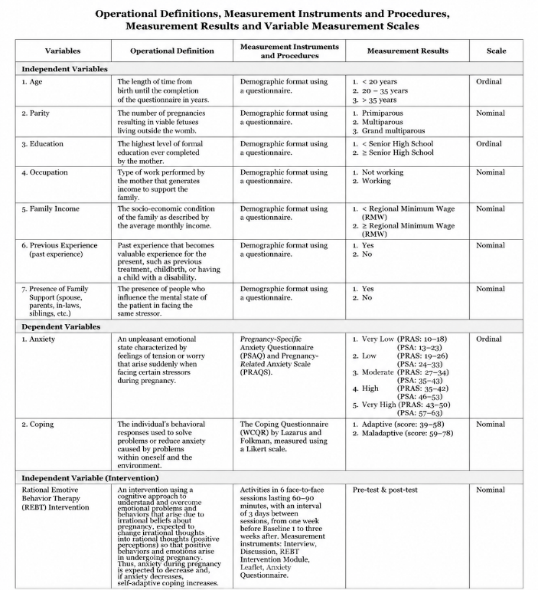

Data Analysis

Univariable analysis data examined the frequency distribution and percentage of the independent and dependent variables using descriptive statistics using Chi-square analysis. Bivariable analysis was conducted to analyze the relationship between two variables using the Chi-square test. To determine the difference in anxiety levels of pregnant women before and after relaxation psychoeducation, a non-parametric test, the Wilcoxon test, was used. Coping quality before and after the intervention was assessed using the Marginal Homogeneity test. The test results were validated with a significance level (p-value <0.01). Logistic regression was also used to examine the effect of the intervention on the quality of coping of pregnant women.

Ethical Consideration
Ethical Considerations
Ethical approval was obtained from the Medical and Health Research Ethics Committee, Faculty of Medicine, Public Health, and Nursing, Padjadjaran University (approval number 281/UN6.C1.2.4/PP/2015).

RESULTS

Participants Characteristics
This study used a Quasi-Experimental Without Control design, comparing anxiety scores and coping skills of pregnant women before and after Rational Emotive Behavior Therapy (RET) intervention. The study began with sample collection on October 22, 2015, following inclusion criteria. The baseline phase was from October 23 to November 6, 2015, with anxiety scale measurements taken three times over a three-week period. The training, module development, and testing of the REBT psychoeducational intervention were supervised by a psychologist. The intervention began from November 17 to December 8, 2015, at the Nilam Sari Community Health Center in Bukittinggi City, West Sumatra.
This study was conducted on pregnant women aged 24–34 weeks with moderate to very high anxiety. The study was conducted door-to-door, or directly visiting the subjects' homes. This chapter presents the results of the data processing and discussion as follows:
Table 3 : Respondent Characteristics

Respondent Characteristics (n = 16)

Descriptive Statistics

Age

< 20 years: 0

20–35 years: 11

35 years: 5

Parity

Primipara: 6

Multipara: 8

Grand multipara: 2

Education Level

≤ Senior High School: 13

Senior High School: 3

Occupation

Employed: 5

Unemployed: 11

Income

< Minimum Wage (UMR): 2

≥ Minimum Wage (UMR): 14

Discomfort in Previous Pregnancy Experience

Yes: 12

No: 4

Cultural Influence

Yes: 0

No: 16

Baseline Anxiety (Baseline Phase)

Very Low: 0

Low: 5

Moderate: 8

High: 3

Very High: 0

Shows that the characteristics of the study respondents show that more than half of them are of reproductive age, namely between 20-35 years old (11 respondents), and multiparity (8 respondents). 13 respondents have a high school education, and 14 respondents have an income equivalent to the Regional Minimum Wage (UMR). The majority of respondents, namely 12 respondents, had unpleasant experiences during pregnancy, both in their current pregnancy and previous pregnancies. There was no cultural influence that made them anxious during their pregnancy. More than half of them had high levels of anxiety during the baseline phase, namely 8 respondents.

Differences in Respondents' Anxiety Scores Before and After the REBT Intervention

Table 4 : Differences in Respondents' Anxiety Scores Before and After the REBT Intervention

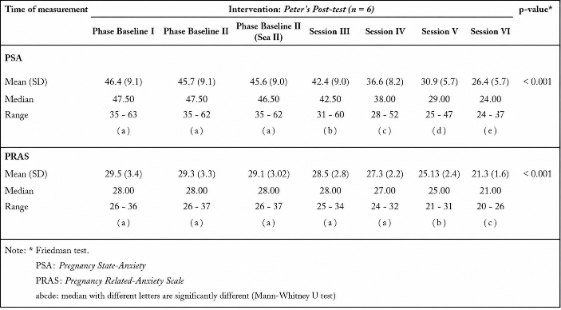

Table 4 shows a difference in the mean, range, and median of the Pregnancy Anxiety Scale (PSA) and Pregnancy-Related Anxiety Scale (PRAS) anxiety scores before and after the intervention, from baseline I to post-intervention. The median calculation, followed by the same letter at baseline, indicates no significant difference based on the Wilcoxon test.

For the Pregnancy Anxiety Scale (PSA), there was a decrease from a median of 47.5 in baseline I (before intervention) to 24 in session VI (after psychoeducational intervention). This score of 24 is considered low anxiety. Similarly, the median score for the Pregnancy-Related Anxiety Scale (PRAS) decreased from 28 to 21, which is considered low anxiety. Therefore, the Friedman Chi-square test concludes that this psychoeducational intervention significantly reduced anxiety scores in pregnant women.

Picture 1 : Changes in Median Pregnancy Scale Anxiety (PSA) and Pregnancy-Related Anxiety Scale (PRAS) Scores

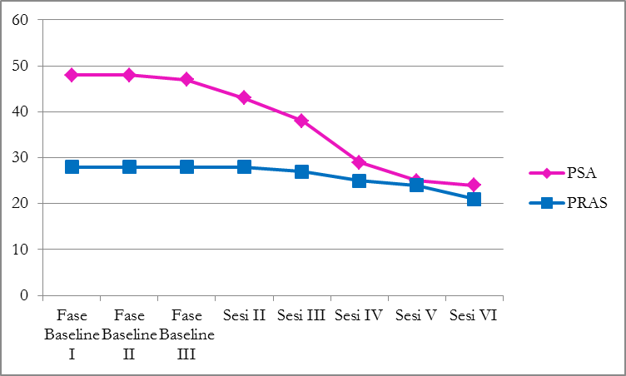

Note: PSA = Pregnancy Scale Anxiety

PRAS = Pregnancy-Related Scale Anxiety

In Graphic 1 shows a decrease in the median Pregnancy Scale Anxiety (PSA) score before and after the intervention. The median score decreased from 47.5 to 24. This indicates a change in anxiety scores from a high to a

low category. Similarly, the median Pregnancy-Related Scale Anxiety (PRAS) score decreased from 28 to 21, indicating a change in anxiety scores from a moderate to a low category.

Differences in Coping Quality Before and After Rational Emotive Behavior Therapy (REBT) Intervention

Table 5 Effect of REBT Intervention on Improving Coping Quality

Table 5 shows a difference in coping quality before and after the Rational Emotive Behavior Therapy (REBT) intervention. For self-coping quality before the intervention, all 16 respondents had maladaptive coping quality. After participating in the intervention, 87.5%, or 14 respondents, experienced an increase in self-coping quality to adaptive. This is also supported by the results of the Marginal Homogeneity Test, which is significant at 0.000 (<0.001), so it can be concluded that there is a difference/improvement in self-coping of pregnant women before and after the intervention.

The Effect of Rational Emotive Behavior Therapy (REBT) Intervention on Reducing Anxiety in Pregnant Women

Table 6 : PSA Assessment Before and After REBT Intervention

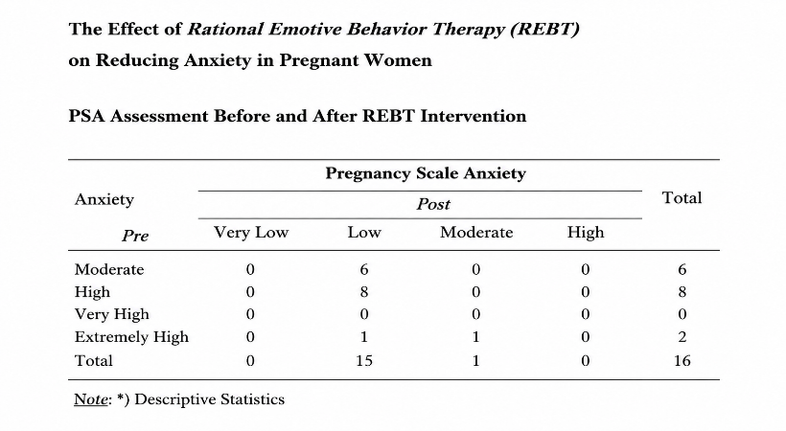

Table 6 shows the results of the Pregnancy Anxiety Scale (PSA) measurement. This measurement aims to assess how often a pregnant woman experiences certain emotions specifically related to pregnancy in the past week. Of the 16 respondents, most had high levels of anxiety before the intervention (8 respondents). After the intervention, anxiety decreased, with the majority (15 respondents) scoring low and one person scoring moderate.

Table 7 : PRAS Assessment before – after Intervention

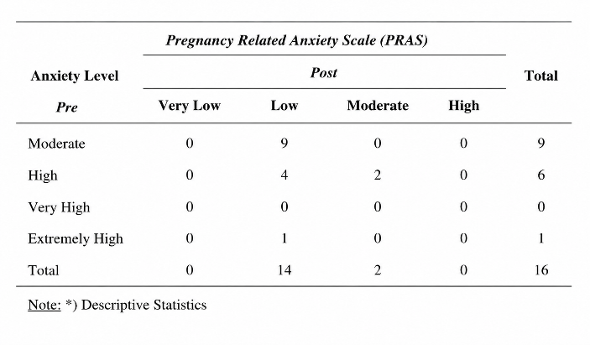

Table 7 shows the results of the Pregnancy Related Anxiety Scale (PRAS), which aims to assess the concerns of pregnant women during pregnancy. Before the intervention, of the 16 respondents, 9 had moderate anxiety, 6 had high anxiety, and 1 had very high anxiety. After the intervention, 14 respondents had low anxiety. These two tables indicate that the REBT intervention has an effect on reducing anxiety in pregnant women.

The Effect of Rational Emotive Behavior Therapy (REBT) Intervention on Improving the Quality of Pregnant Women's Coping

Table 8 : Copyng Before and After the REBT Intervention

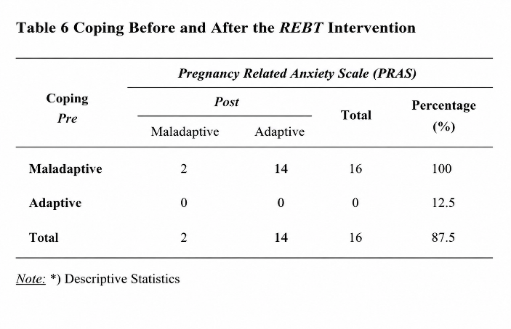

In Table 8, it is known that there was an increase in the quality of self-coping of pregnant women before and after the intervention, namely, of the 16 respondents, the majority had adaptive self-coping, namely 14 respondents who previously had maladaptive coping mechanisms overall.

The Effect of REBT Intervention on the Quality of Pregnant Women's Coping

Table 8 shows that the REBT intervention had a

statistically significant effect on the quality of pregnant women's coping. This is evident in the table, where the estimated value is 29, meaning that pregnant women's coping is 29 times more likely to become adaptive after the REBT intervention. The results of this study have a significant ratio, meaning they can represent the entire population.

Hypothesis Testing

Based on the statistical analysis results used in this study, the research hypothesis must be proven using statistical tests. The proof of this hypothesis in this study will be described as follows:

1. First Hypothesis
Rational Emotive Behavior Therapy (REBT) intervention can reduce anxiety in pregnant women.

Supporting Evidence:
Table 5 shows that during the Rational Emotive Behavior Therapy (REBT) intervention, the anxiety scores of pregnant women gradually decreased until after the intervention. Based on the results of the two tests, the Friedman Test and the Wilcoxon Test, with a p-value <0.001, it can be concluded that the Rational Emotive Behavior Therapy intervention has an effect on reducing anxiety in pregnant women. This is further supported by diagram 4.1, which shows differences in anxiety scores in pregnant women at each stage leading up to the end of the intervention.
Disadvantages: None
Conclusion: Hypothesis 1 is accepted.

2. Second Hypothesis
Rational Emotive Behavior Therapy (REBT) intervention can improve adaptive coping in pregnant women.
Supporting Facts:
Table 6 shows that the quality of pregnant women's coping before and after the Rational Emotive Behavior Therapy intervention increased toward adaptive outcomes. More than half, or 87.5%, of the 14 respondents, reported this. This is further supported by the analysis results, which obtained a p-value <0.001, or 0.000, indicating a significant difference between before and after the intervention.
Disadvantages: None
Conclusion: Hypothesis 2 is accepted

3. Third Hypothesis
There is an effect of Rational Emotive Behavior Therapy (REBT) intervention on reducing anxiety and improving the quality of pregnant women's coping.
Supporting Facts:
Table 5 shows that pregnant women's anxiety decreased before and after the Rational Emotive Behavior Therapy intervention. Similarly, Table 6 shows that the quality of pregnant women's coping before and after the intervention increased toward adaptive outcomes. This is further supported by the analysis results, which obtained a p-value <0.001, or 0.000, indicating a significant difference between before and after the intervention. In terms of self-coping, pregnant women develop new rationales and utilize positive coping strategies based on these new rationales. This is evident in the evaluation of their cognitive, emotional, and attitudinal responses.
Conclusion: Hypothesis 3 is accepted.

DISCUSSION

Rational Emotive Behavior Therapy (REBT) intervention can reduce anxiety in pregnant women. Supporting evidence: Table 4 shows that during the Rational Emotive Behavior Therapy (REBT) intervention, pregnant women's anxiety scores gradually decreased until after the intervention. Based on the results of the two tests, the Friedman Test and the Wilcoxon Test, with a p-value <0.001, it can be concluded that the Rational Emotive Behavior Therapy intervention had an effect on reducing anxiety in pregnant women. This is further supported by the differences in anxiety scores in pregnant women at each stage leading up to the end of the intervention in graphict picture 1. Disadvantages: None. Conclusion: Hypothesis 1 is accepted. Second Hypothesis

Rational Emotive Behavior Therapy (REBT) intervention can improve the quality of pregnant women's coping towards adaptive coping. Supporting evidence:Table 4.3 shows that the quality of pregnant women's coping before and after the Rational Emotive Behavior Therapy intervention increased towards adaptive coping. More than half, or 87.5%, of the 14 respondents, responded. This is further supported by the analysis, which obtained a p-value <0.001, or 0.000, indicating a significant difference between before and after the intervention. Conclusion: Hypothesis 2 is accepted.

3. Third Hypothesis. There is an effect of Rational Emotive Behavior Therapy (REBT) intervention on reducing anxiety and improving the quality of pregnant women's coping. Supporting Facts at Table 5 shows that pregnant women's anxiety decreased before and after the Rational Emotive Behavior Therapy intervention. Similarly, Table 6 shows that pregnant women's coping quality improved toward adaptive coping before and after the intervention. This is further supported by the analysis, which obtained a p-value <0.001, or 0.000, indicating a significant difference between before and after the intervention. From a coping perspective, pregnant women developed new rationales and used positive coping strategies based on these new rationales. This is evident from the evaluation of their cognitive, emotional, and attitudinal responses. None Unsupported factors and Conclusion Hypothesis 3 is accepted

DISCUSSION OF RESEARCH RESULTS

This study aimed to examine the effect of psychoeducation using the Rational Emotive Behavior Therapy method on reducing anxiety symptoms in pregnant women and, hopefully, to reflect adaptive maternal coping. The following research results were obtained:

1. Characteristics of Research Subjects
Table 4 shows that more than half (68.8%) of the 16 respondents, namely 11 respondents aged 20-35 years and older, were unemployed. 13 respondents had an education equivalent to or below high school (SMA). 14 respondents had incomes above or equal to the Regional Minimum Wage (UMR). 12 respondents had unpleasant experiences during pregnancy, either in the current pregnancy or in previous pregnancies.

In direct observation, respondents had high anxiety scores, especially those with high-risk pregnancies (>35 years old) and who had had unpleasant experiences in previous and current pregnancies. Anxiety disorders can occur at any age. Age influences a person's psychological well-being, but it does not guarantee maturity in responding wisely to their experiences. The older a person gets, the better their emotional maturity and ability to deal with various challenges

Education is generally useful in changing thought patterns, behavior patterns, and decision-making. It influences awareness and understanding of stimuli, making it easier to identify internal and external stressors. People from lower socioeconomic levels often experience psychological disorders. Income is influenced by a person's type of work, which determines how well they can meet the needs of themselves and their families.

Early experiences are invaluable, as they significantly influence mental health and the ability to cope with similar stressors. Therefore, researchers assume these factors trigger anxiety in pregnancy, giving rise to irrational thoughts that lead to anxiety. Therefore, coping tends to be maladaptive, meaning the inability to defend oneself against any situation or circumstance, and the tendency to respond positively to any thoughts.3,39,40

2. Rational Emotive Behavior Therapy (REBT) intervention has an effect on reducing anxiety in pregnant women.

This study was conducted to determine the effect of Rational Emotive Behavior Therapy (REBT) intervention on reducing anxiety and improving the quality of coping in pregnant women before and after the intervention. The results showed a statistically significant effect on the REBT intervention in reducing maternal anxiety.

The absence of a measurable association during acute illness may be explained by the dominant physiological responses triggered by infection. Acute illness induces metabolic reprioritization toward immune defense and tissue repair, characterized by increased basal metabolic rate, inflammatory-mediated gastrointestinal dysfunction, and reduced appetite. These processes collectively create a transient catabolic state that suppresses growth, regardless of caregiving quality. Even optimal nurturing practices may be insufficient to counteract this metabolic stress during the acute phase, although they likely support more rapid recovery once illness resolves.²¹

In contrast, the effects of nurturing care are inherently cumulative and manifest over extended periods. Longitudinal studies have shown that caregiving quality predicts changes in child growth indicators only after months or years of consistent exposure.22 The cross-sectional design of this study captured children during an acute physiological stress period, potentially preceding the timeframe in which nurturing care benefits translate into observable growth recovery. This temporal mismatch may partly explain the null statistical findings.

The nearly equal distribution of good and poor nurturing care practices observed in this study contrasts with reports from healthy child populations, where good practices are typically more prevalent.²³ Caring for acutely ill children imposes additional demands on caregivers, including managing altered child behavior, medication administration, frequent health facility visits, and feeding difficulties due to illness-related anorexia.13 These concurrent stressors may temporarily compromise caregiving quality, even among otherwise capable caregivers, highlighting acute illness as a vulnerability period for both children and caregiving systems.

The lack of association between socioeconomic factors and child growth aligns with evidence suggesting that socioeconomic status influences child outcomes indirectly through proximal caregiving behaviors rather than through direct pathways.²⁴ Families with limited economic resources may compensate through extended family support and culturally embedded caregiving practices. Previous studies indicate that maternal responsiveness, emotional availability, and psychological well-being mediate the relationship between socioeconomic conditions and child growth, reinforcing the notion that caregiving quality may transcend economic boundaries when adequate knowledge and support are present.²⁵

The proportion of children experiencing inadequate weight gain in this study is consistent with findings from other studies of acutely ill pediatric populations.26 Growth outcomes during illness are influenced by a complex interaction of disease severity, baseline nutritional status, inflammatory burden, and cumulative illness exposure.27 While single episodes of acute illness may be compensated by children with adequate nutritional reserves, repeated or prolonged infections without sufficient recovery can
progressively impair growth trajectories.28

Evidence examining comprehensive nurturing care in acutely ill populations remains scarce. Most existing research focuses on healthy children or isolates specific caregiving behaviors such as feeding or healthcare utilization. Studies that have assessed caregiving during illness have similarly reported null associations, attributing findings to the multifactorial nature of growth regulation.29 In contrast, structured nurturing care interventions that provide systematic caregiver training, supervision, and continued support have demonstrated significant improvements in child growth outcomes.30,31 These programs likely sustain caregiving quality throughout illness and recovery by buffering parental stress and promoting illness-adapted caregiving strategies—elements that are typically absent in routine, unstructured caregiving contexts.32

This study contributes to the limited body of evidence on nurturing care among acutely ill children, a population frequently underrepresented in child development research. Strengths include the use of standardized World Health Organization growth references, validated measurement instruments, and data collection in a high-volume Integrated Management of Childhood Illness setting, enhancing clinical relevance. However, several limitations should be considered. The single-site design restricts generalizability, and the two-month interval used to assess weight change may not fully capture longer-term growth recovery following illness. Additionally, the cross-sectional design precludes causal inference and limits assessment of cumulative caregiving effects over time.

CONCLUSIONS AND RECOMMENDATION

This study indicates that Rational Emotive Behavior Therapy (REBT) has a significant effect on pregnant women with moderate to very high levels of anxiety. The intervention is effective in reducing anxiety and improving coping skills among pregnant women.

The observed changes are characterized by a shift from irrational to rational thinking patterns, leading to more realistic and adaptive cognitive responses. This cognitive restructuring contributes to improved emotional stability and enhanced coping capacity in managing pregnancy-related stressors.

Therefore, REBT can be recommended as an effective psychological intervention within antenatal care services for the early identification and management of anxiety in pregnant women. It is also suggested that structured mental health care components be integrated into maternal health services as part of comprehensive antenatal care. Such integration is expected to strengthen psychologically based midwifery care and support efforts to reduce maternal and neonatal health risks.

Acknowledgement

The authors would like to thank all pregnant patients who participated in this treatment program. They also thank the local city government and the community health center (Puskesmas) that covered the monitoring area where patients were found with anxiety disorders during pregnancy that exceeded normal limits. They also thank the Faculty of Medicine, specifically the Master of Obstetrics and Public Health, Padjadjaran University.

REFERENCES

Larasati IP, Wibowo A. Pengaruh Keikutsertaan Senam Hamil Terhadap Kecemasan Primigravida Trimester Ketiga Dalam Menghadapi Persalinan, Biometrika dan Kependudukan , 2012. 1(1):26-32.

WHO, Maternal mental health and child health and development in low andmiddle income countries, . Report of The Meeting held in Geneva,Switzerland. 2008,30 january - 1 February.

GuardIno, Crhistine m, Dunkel Schetter. Understanding Pregnancy Anxiety Concepts, Correlates, and Consequences. Zero to three.2014 March.

Texeria J & Glover W. Association Between Maternal Anxiety In Pregnancy And Increases Uterine Artery Resistancy Index. BMJ 1999;318(7177).

Leigh B, Milgrom J. Risk Factors For Antenatal Depression, Postnatal Depression And Parenting Stress. BMC Psychiatry. 2008.

Michelle Haring PD, R. Psych., Jules E. Smith M, et al, FRCPC coping with anxiety during pregnancy and following the birth The BC Reproductive Mental Health Program BC Mental Health & Addiction Services, An Agency of the Provincial Health Services Authority A cognitive behaviour therapy-based self-management guide for women and health care providers. The BC Reproductive Mental Health Program BC Mental Health & Addiction Services, An Agency of the Provincial Health Services Authority. 2013;1.

Elseiver Mosby: St Louis Missouri,The priciple and practice psyciatric nursing. 8 ed. 2005.

Ellis, Albert, Larrent C Mac. Rational Emotive Behavior Therapy A Therapy's Guide. California: Impact Publisher; 1998.

Froggat. A Brief Introduction to Rational Emotive Behavior Therapy. Journal Of Rational Emotive Behavior Therapy 2005.

Mottaghipour, Bickerton. psikoedukasi memperkuat strategi coping. 2005.

Lukens, McFarlane EP, R W, . Psychoeducation as Evidence-Based Practice: Consideration for Practice, Research, and Policy. Journal Brief Treatment and Crisis Intervention 2004;Volume 4.

Roy. depresi dan solusinya. http://www.wordpress.com. 1999.

Mohammad B, Farhad F. Psychoeducation for Bipolar Mood Disorder. Treatment Approaches to Affective Disorders. 2010.

D. H. Manejemen Stres, Cemas, dan Depresi. Jakarta: Balai Penerbit Fakultas Kedokteran Universitas Indonesia.; 2005.

Zainie H. Gambaran Cemas & Depresi pada Hasil Survey Kesehatan Jiwa Ibu Hamil dan Meneteki di 112 Puskesmas 24 Kabupaten/kota Propinsi Jawa Barat September - Nopember Tahun 2003 Bandung: Bagian Psikiatr FKUP / RSHS Bandung, Fakultas Kedokteran Universitas Padjadjaran Bandung; 2006.

A,Sudiyanto. Bimbingan Teknis Psikoterapi : Cognitive Behavior Therapy (CBT) FK UNS; 2007.

Nuhriawangsa. Konsep Dasar Stres, Simposium penyesuaian diri terhadap stres di masa krisis moneter, Pelantikan Dokter Baru Periode 124, FK UNS, Surakarta.1998.

Official T, Psychiatry. JotCJo. Clinical Practice Guidelines Management Of Anxiety Disorders. July 2006, ; 51(2).

Sadock K. Text Book of Psychiatry American 2005.

Therapy NACBT. What is Cognitive Behaviour Therapy. http://NACBT.com.2008.

Misri, S & Kendrick K. Treatment of Perinatal Mood and Anxiety Dissorders. can J psycyatri 2007;52.

J.Gibson, K.Mc Kenzie - McHarg 1, J. Shakespeare2, J. Price 3, R.Gray. A Systematic Review Of Studies Validating The Edinburgh Postnatal Depression Scale In Anteprtum and Postpartum Women. Acta Psychiatr Scand : 119 : 350 - 364. All rights Reserved DOI : 10.1111/ j.1600-0447.2009.01363.x

Lorraine B Sanders, CNM, APRN,DNSC. Assesing and Managing Women With Depression : A Midwifery Perspective. Journal of Midwifery & Women's Health. www.jmwh.org 185 .2006 by The America College of Nurse-Midwives 1526-9523/06/S32.00.doi:10.1016/j.jmwh.2005.10.002 Issued by Elsevier Inc.

Toosi M, Akbarzadeh M, Sharif F, Zare N. Women’s Health Bulletin The Reduction of Anxiety and Improved Maternal Attachment to Fetuses and Neonates by Relaxation Training in Primigravida Women. 2014 Apr; 1;1(1e18968.).

Mancuso et al. Maternal Antenatal Anxiety Corticotropin Releasing Hormone Associated With Timing Of Delivery. American Psychosomatic Society.Psychosomatic Medicine; 2004, 66:762-769

Correia LL, Linhares MBM. Maternal anxiety in the pre and post natal periode. rev latino-am emfermagem. 2007;15(4):83.

Geetha Shivakumar,M.D.,M.S, Antenatal Deression: A Rationale For Studying Exercise. NIH Public Access Author Manuscript Depress Anxiety. PMC. Depress Anxiety;2012, March,28(3):234-242

Keliat. penatalaksanaan stres. jakarta: EGC; 1999.

Anton R.Miller, Magdalena A.Recsky,Robert W.Amstrong. Responding To The Needs Of Children With Chronic Health Care In An Era Of Health Service Perform. Journal Of Canadian Medical Assosiation (JAMC) 2004;171(11): 1366-1367

Taylor.Lazarus,Cohen. Stress Apraisal Coping.1991.

Joseph W. Psycheducation In Mental Health:INC.2010

Gerald, Correy. Teori dan Praktek Konseling dan Psikoterapi. Bandung: PT Refika Aditama; 2007.Timms, Gosselin. Cognitive Behaviour Therapy. 2007.

Timms,Gosselin.Cognitive Behaviour Therapy.2007

Nevid.Cognitive Behaviour Therapy.2005

Dryden,W.Rena Branch. The Fundamental Of Rational Emotive Behavior Therapy A Training Handbook Second Edition. England: John wiley & Sons Ltd; 2008.

Cochran WG. sampling techniques. thirded: Harvard University; 1977.

Cristensen L. Eksperimental Methodology. 2004.

S,Azwar. Penyusunan Skala Psikologi. Yogyakarta: Pustaka Pelajar; 1999.

Georgia Ave.Generalized Anxiety Disorder Association of.Anxiety Disorders America 8730 SSS, MD 20910.

Nazara,. 216-222.Majalah Obstetri

